**BOUTIQUE BI project**

Team Member:

Djeninah TIMOTHEE

Fred Junior NOEL

Moise MASSON

1. **Introduction**
2. **Recognize the business problem**
3. **Methodology**
4. **Results**
5. **Develop alternative solutions**
6. **Present the Solution**

1. **Recommandations**
2. **Référence**
3. **Introduction**

We are the MFD Consulting Group, a consulting and research firm. Consisting of three analysts of different specialties (Data Analytics, Data Science, Business Analysis). We have been mandated for a period of three (3) months to realize a "BI solution" to the problem Michel's Boutique is facing.

1. **Recognize the business problem**

For the past three months, the store has had some problems with tomato paste orders. When analyzing the operation of the store, they realized that they were buying too many cans. In fact, the company buys tomato concentrate every two (2) weeks, but since it is a perishable product, after a period of one month, they have to throw away several cans. It faces a recurrent loss of tomato concentrate and it is clear that at this rate, this loss could be synonymous with a deficit. Since then, he asks himself this question: should the store continue to sell tomato paste or not? Mr. Michel wonders if there is a way to minimize his losses.

Faced with this question, the company's problem is defined as follows: "How can the company continue to sell tomato paste without making a deficit? It is to answer this question that the son of the owner of the store contacted our firm "MFD Consulting Group".

* 1. **Identify your client**

Our client is Michel, entrepreneur, owner of Michel's Boutique. He is male, in his sixties, and a father. He is a hard-working, industrious man who is very committed to the values of his business. His family fortune is the basis for the development of his business.

* 1. **Research the organization**

The company's profile needs to be defined. For this, the project team used a "Business model Analysis" which is an overview of how the company plans to make money with its products and customers in a specific market. The idea is to better understand the company in order to address its problem. Basically, the business model explains four things:

* Type of Product / Service
* Commercialization
* The Cost
* The Profit

The following table is a summary of the information received by the owner. In summary: Michel's Boutique is a family business operating in Haiti. It is run by Mr. Michel, the owner of the boutique and his son as manager. It competes in two (2) competitive markets: household goods and food products. It is made up of seed funds, mainly family funds. Michel's Boutique wants to be a company.

**Table 1. Business Model Analysis**

|  |  |  |  |  |
| --- | --- | --- | --- | --- |
| **MICHEL'S BOUTIQUE BUSINESS MODEL** | | | | |
| **Keys Partners** | **Keys Activities** | **Value Proposition** | **Customer Relationship** | **Customer segments** |
| *Key partners are the people you work with to create a strategic relationship*   * Distribution partners * Wholesaler * Retailers * Suppliers | *Key activities are specific tasks that are fundamental to business operations*  **Household goods** ;  **Food products** ;   * Bi-Weekly Programming of Orders * Storage * Product display * Product sale | *Value Proposition is the primary driver of business operations*   * Good quality product * Satisfied Customer * Cheaper product * Diversified product | *Customer relationships are the types of interactions a company has with its customers*   * Good relationship with the customer * Exchanges and suggestions * Appreciation of the customer service | *Customer Segmentation divides a customer base into groups of people similar in specific ways. This may be based on gender, age, interests, and spending habits.*   * Housewives aged 20 to 50 years; * Men aged 30 to 64 years * Marchants de nourriture |
|
|
|
|
|
|
|
|
|
|
|
|
|
| **Keys**  **Ressources** | **Channels** |
| *Key resources are the assets required to operate and deliver your value proposition.*   * Buildings * Sogebank lending * Family’s fund * Trained staff * Patent | * Media advertising * Home delivery * Discount * Special price per package * Diversified payment method, * Product return, * Online advertising, * Subscription, customer loyalty |
|
|
|
|
|
|
|
|
|
| **Cost Structure** | | | **Revenue Stream** | |
| *The cost structure refers to how a company spends money on operations*   * Michel’s Boutique is focused on delivering product at low costs * No middleman in the supply chain   Wholesale orders   * Buy cheap, Sell cheap | | | *Revenue streams are a company’s source of cash flows*   * Household appliances * Revenue on Tomato paste Brand A * Revenue on Tomato paste Brand B * Revenue on Tomato paste Brand C | |
|
|
|
|
|
|
|
|

**Source** : <https://alcorfund.com/insight/what-is-a-business-model-canvas/>

* 1. **Identify relevant stakeholders**

A directory was compiled to better understand the impact of the problem on the stakeholders who influence the company's operations. The stakeholders include: The owner of the company (Michel), the manager (Mr. Michel's son), the minority shareholders in the company (bank, individuals or family members), the human resources director (HRD), the marketing manager (RM), the supply manager (RA), the staff members of the company, the suppliers (Suppliers), and the customers (Clients).

**Figure 2. Ecosystem stakeholders**



In the following table, we present the impact of the problem on the key actors of the company as well as the degree of importance that each actor gives to the problem:

**Tableau 3. How Stakeholdersare impacted by the problem**

|  |  |  |
| --- | --- | --- |
| **Stakeholders** | **Key Relationship** | **Measurement** |
| Owner | The store owner is the first stakeholder. He does not make a profit because he throws away several cans of tomato paste every month. | Very Severe |
| Shareholders | Their profit margin could decrease | Very Severe |
| Manager | He could lose his job | Very Severe |
| Staff management  (DRH, RM et RA) | Their benefits could be reduced and the RA could lose their job. | Not severe  (leur emploi est assuré) |
| Staff member (salesmen, deliverymen, drivers) | If this problem is not solved it could lead to a reduction in staff. | Not severe |
| Tomato producers | losing a customer who orders every two weeks would be a capital loss. | Not severe  (the market is competitive) |
| Customers | His customers are also affected. Michel throws away the products every month because some customers do not buy or they buy in small quantities, so there is a problem, if the owner decides to stop selling tomato paste it will affect those who used it. Ils seront obligés de s’approvisionner ailleurs | Not severe |

1. **Methodology**

Our solution has been proposed to the owner who is Michel. Since the last three months the owner is preoccupied by his orders of tomato paste and there is no profit and a loss every month. His source of motivation is to help his father to solve this problem.

Our project team uses a mixed methodological approach by combining the proposed Project Roadmap with the Work Breakdown Structure (WBS) approach which consists in breaking down the project into steps and then into activities. The team proposes to present the appropriate solution to the problem of Mr. Michel's store using two (2) steps broken down into six (6) activities:

**Tableau 4. WBS of the BI solution**



* 1. **Profile Description**

The Profile Description consists in presenting the client and his business. We have analyzed Michel's Boutique's business model with the little information we have. This is what we have just done in the previous paragraphs.

* 1. **Descriptive analysis**

We used the company's purchase and sales records (Dataset) and supply chain information to perform our initial analyses. We took into account four (4) variables: Total sales, Sales/month, Sales/Brand, Total cost, Cost/month, Cost/Brand, Total quantity sold, Quantity sold/month, Quantity lost, Quantity lost/month, Quantity/Brand:

**Table 5. Definition of variables**

|  |  |
| --- | --- |
| Total sales | This is the total amount of products sold |
| Sales/month | Total products sold per month |
| Sales/Brand | Total products sold by brand |
|  |  |
| Total Cost | Total sum of costs for all products |
| Cost/month | Product costs per month |
| Costs/Brand | Product costs by Brand |
|  |  |
| Total quantity sold | Total quantity of products sold |
| Quantity sold/month | Quantity of products sold per month |
| Quantity sold /Brand | Quantity of products sold by brand |
|  |  |
| Total quantity lost | Total quantity of expired products |
| Quantity lost/month | Total quantity of expired products per month |
| Quantity/Brand | Total quantity of expired products per Brand |

These key variables are important in calculating the Gross Profit which is the total Profit or Loss that the store could make during the quarter. We will use the "Tracking method" to trace the quantities lost on each order due to overlaps. In order to know what really happened in the company, it is imperative to collect, process and manipulate the data. The results of this initial data manipulation will be used to describe the company's situation.

The Descriptive Analysis revealed that at a certain point, a certain amount of tomato pasta remains unsold. In fact, the sales of tomato pasta decreased by 6% for the month of January and by 15% for the month of February.

|  |  |  |  |  |  |
| --- | --- | --- | --- | --- | --- |
| **TABLE OF FINANCIAL OPERATIONS** | | | | | |
| OPÉRATIONS | **December 2019** | **January 2020** | **February 2020** | **Total** | **Weight** |
| **I. Total sales (I.1+ I.2+I.3)** | **64 650** | **60 750** | **55 275** | **180 675** | **100%** |
| **I.1 Brand A** | 21 550 | 20 250 | 18 425 | **60 225** | 33% |
| **I.2 Brand B** | 20 688 | 19 440 | 17 688 | **57 816** | 32% |
| **I.3 Brand C** | 22 412 | 21 060 | 19 162 | **62 634** | 35% |
| **II.Total costs (II.1.1 + II.1.2+ II.3)** | **64 423** | **122 134** | **121 277** | **307 833** | **100%** |
| **II.1 Brand A** | 20 473 | 41 159 | 40 090 | **101 721** | 33% |
| **II.2 Brand B** | 22 400 | 46 550 | 44 987 | **113 937** | 37% |
| **II.3 Brand C** | 21 550 | 34 425 | 36 200 | **92 175** | 30% |
| **III. Total profit(+) or loss(-)** | **228** | **-61 384** | **-66 002** | **-127 158** | **100%** |
| **III.1. Brand A** | 1 078 | -20 909 | -21 665 | **-41 496** | 33% |
| **III.2 Brand B** | -1 712 | -27 110 | -27 299 | **-56 121** | 44% |
| **III.3 Brand C** | 862 | -13 365 | -17 038 | **-29 541** | 23% |

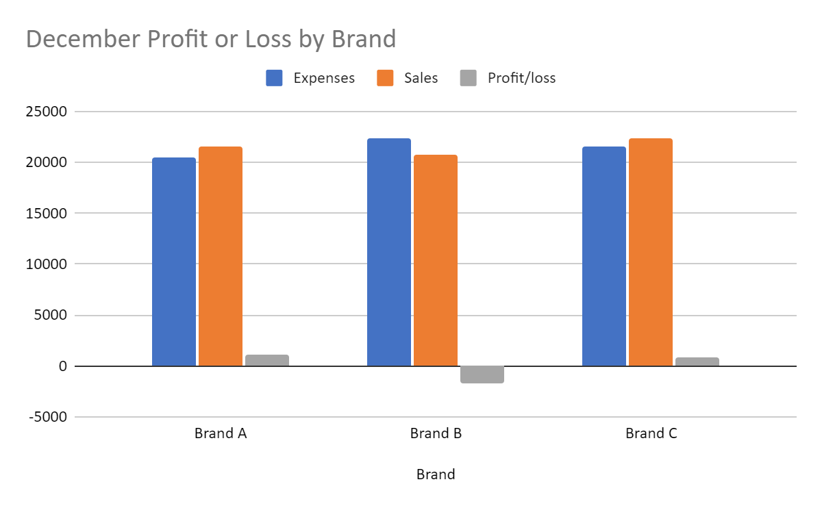

At the beginning of the fiscal year, in December, the Boutique Company did not show any loss for the brands A and C. On the contrary, the sales volumes of these two brands are higher than their costs. But, unfortunately, for the product B, a loss has been registered.

These results can be explained by the fact that at the beginning of the year, there are no expired products and each sale is a direct gain for the company.

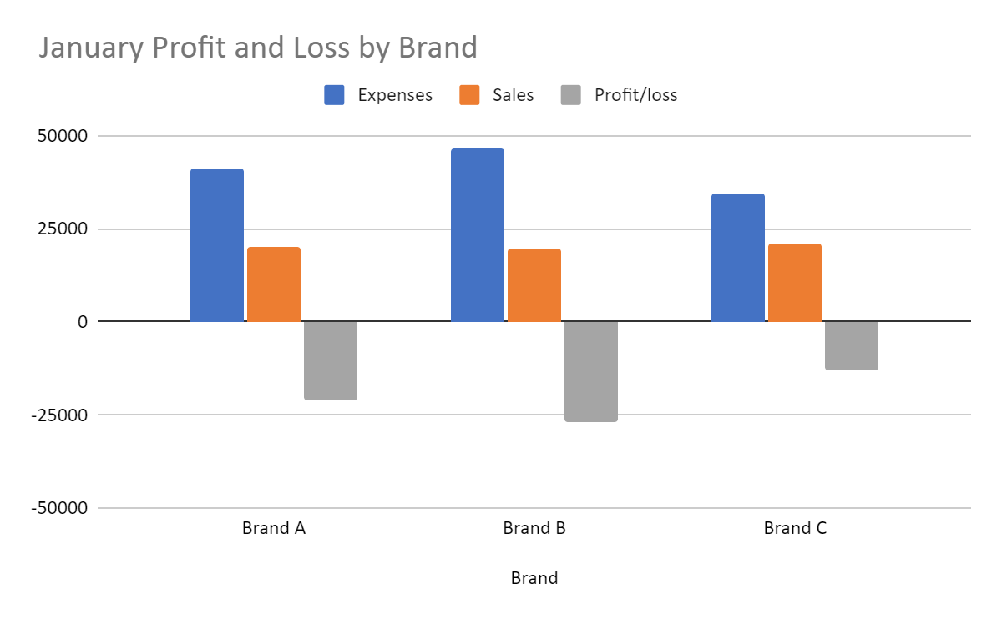

For the month of January, the Boutique Company has made a loss for all brands: A, B and C. B.

Brand B is still the most unfavorable in terms of yield.

A good explanation would be that at the beginning of January there was a large quantity of lost products. These products have a cost, so they will negatively affect its profit margin.

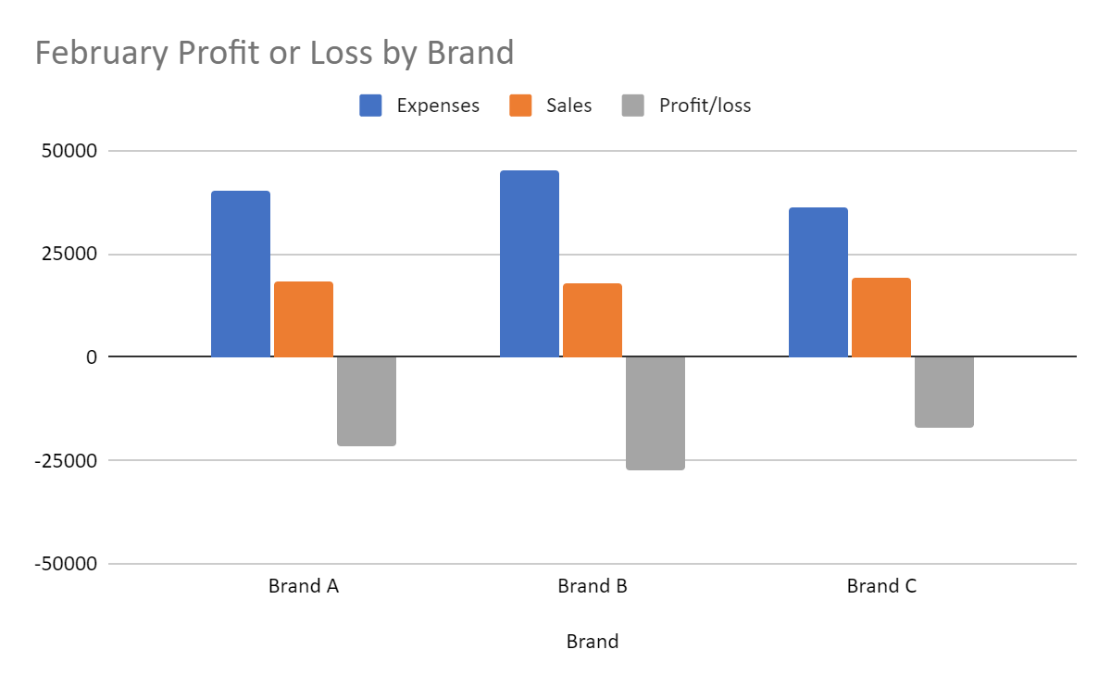

In February, we notice that the situation has not changed, if not worsened.

In spite of the accounting hypothesis: first in, first out. The losses are accumulating, because the brands have a shelf life of one month and in spite of the losses of January, the same amount of products has been ordered.

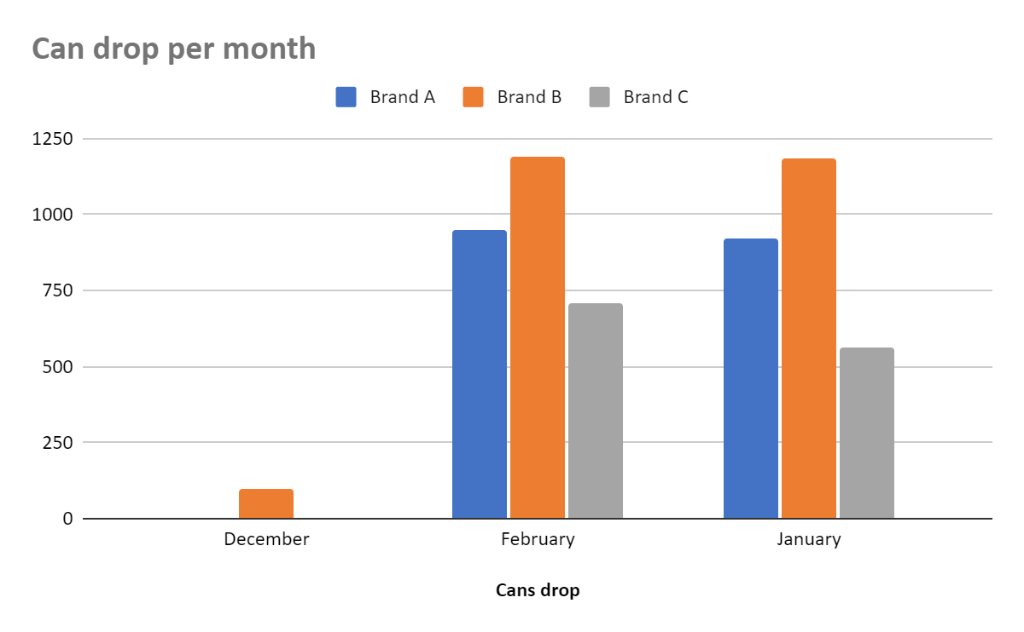

Here we have a graph of the quantity of **expired products** per month and per brand.

This graph joins our previous analysis on another angle, that of costs.

Directly, the brand B costs the most to the Company. We can say that it is the brand of product least preferred by the customers.

* 1. **Diagnostic Analysis**

In order to find out why and how the problem occurred, a SWOT analysis was conducted, which revealed that the company is severely lacking in financial information. It is poorly equipped with financial management tools. Replenishment time presents a challenge for the store. Due to multiple fierce competitors in the food market, Michel's boutique is at greater risk of a deficit if losses continue.

**Table 6. SWOT Analysis**

|  |  |
| --- | --- |
| **STRENGTH** | **WEAKNESS** |
| * Register of purchases and sales (Dataset) * Selling multiple brands of tomato paste (A, B and C) * Regular replenishment * Qualified human resources | * Lack of information ; * Missing management tools * Short deadline ; * Not enough information about the company's stakeholders; * Insufficient assets |
|
|
|
|
|
|
|
|
|
|
| **OPPORTUNITIES** | **THREATS** |
| * Discerning clientele; * Several suppliers; | * Perishable product in one (1) month ; * Competitive market |
|
|
|
|
|
|
|
|
|
|

1. **Develop alternative solutions**

**Solution 1:**

Michel's Boutique needs to define an alternative replenishment schedule that would take into account the amount of tomato paste sold per month (only buy what they can sell).

**Benefit 1:** Our team found that the problem of product waste is mainly in the supply chain. Indeed, restocking every two (2) weeks is partly responsible for unsold products. It would be better for Michel to wait until a stock is depleted before making new orders, otherwise he would always have unsold products**.**

**Disadvantages 1:** This would require buying less tomato concentrate which would amount to. The tomato paste producers will be penalized with this solution because they will lose orders which will be a loss of profit.

**Solution 2:** The alternative solution proposed by our team is the following: If Michel is not satisfied with the first solution, Michel's Boutique could conduct a market study in order to have a more precise idea of the opportunity cost of selling tomato pasta and a customer satisfaction survey on the three brands of tomato pasta in order to identify the causes of this downward trend in sales, make the choice between an acceptable but assured profit and the search for a greater but risky profit.

**Advantage 2:**

Another observation about unsold tomato pasta is that sales are decreasing. Sales of tomato pasta have decreased by 6% for the month of January and by 15% for the month of February. A market study and a customer satisfaction survey are mandatory in this case.

**Disadvantages 2:**

This solution requires investment and time to implement a new strategy.

1. **Present the Solution**

The proposed solution is as follows : define an alternative replenishment schedule that would take into account the amount of tomato paste sold per month (only buy what they can sell).

**Recommendations**

As a recommendation, we advise the owner of Michel's Boutique to train the company's executives in management.

.